**Project 4**

**Hosting a static website using S3 Bucket.**

S3 bucket

Steps: 1. Go to search bar and type s3. Click on s3.

2. In S3 dashboard, go to general purpose buckets and click on create bucket button.

3. In general configuration, select bucket type as general purpose and give name as likhinbucket1234.

4. Click on create bucket button. Your bucket is created.

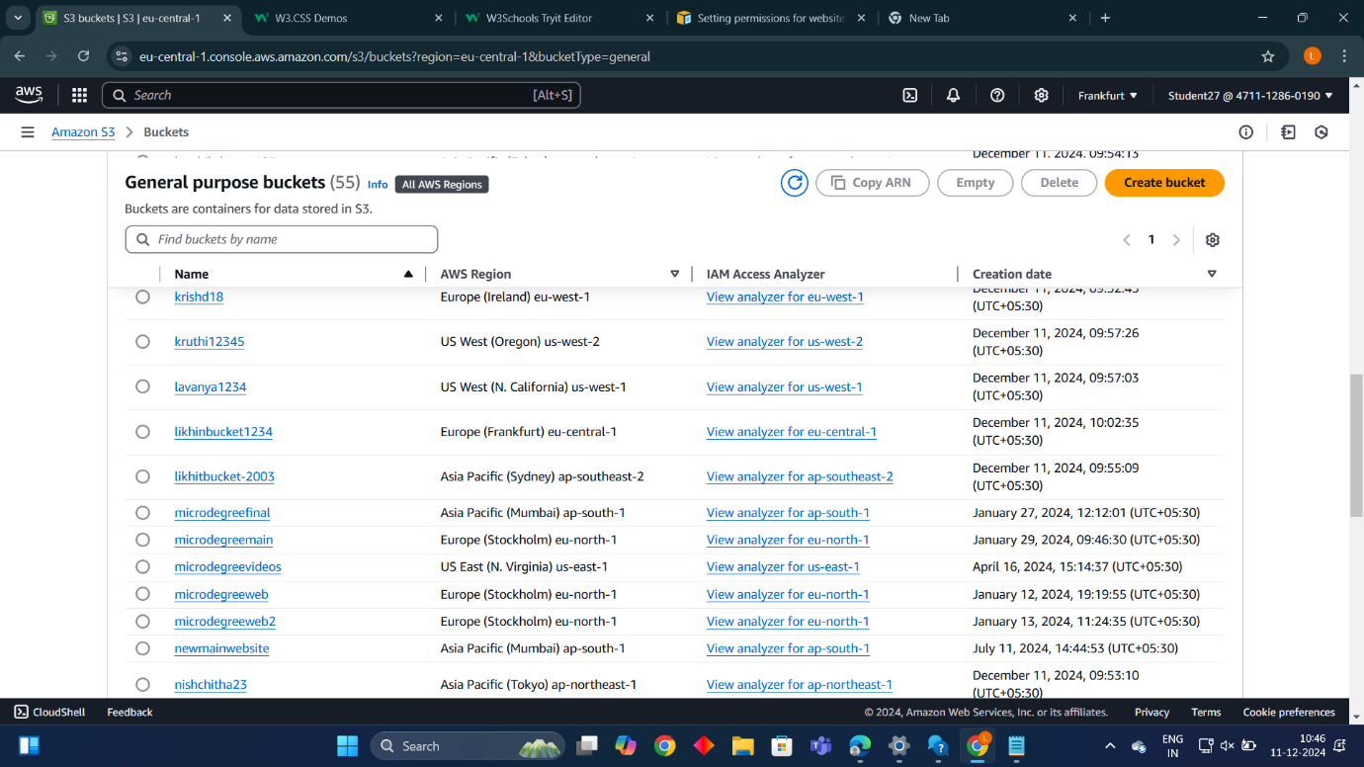

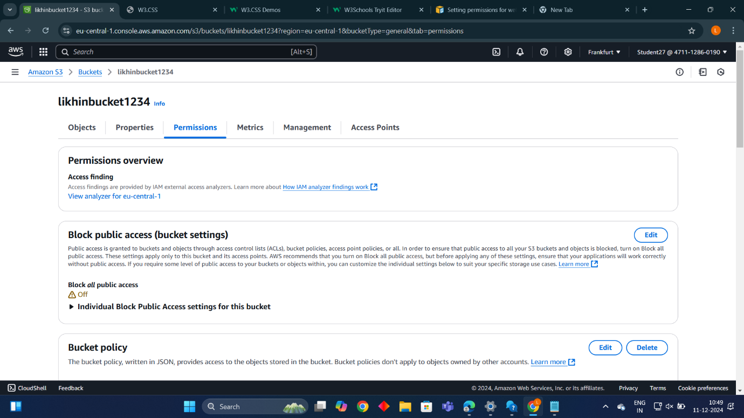

**Uploading a file:**

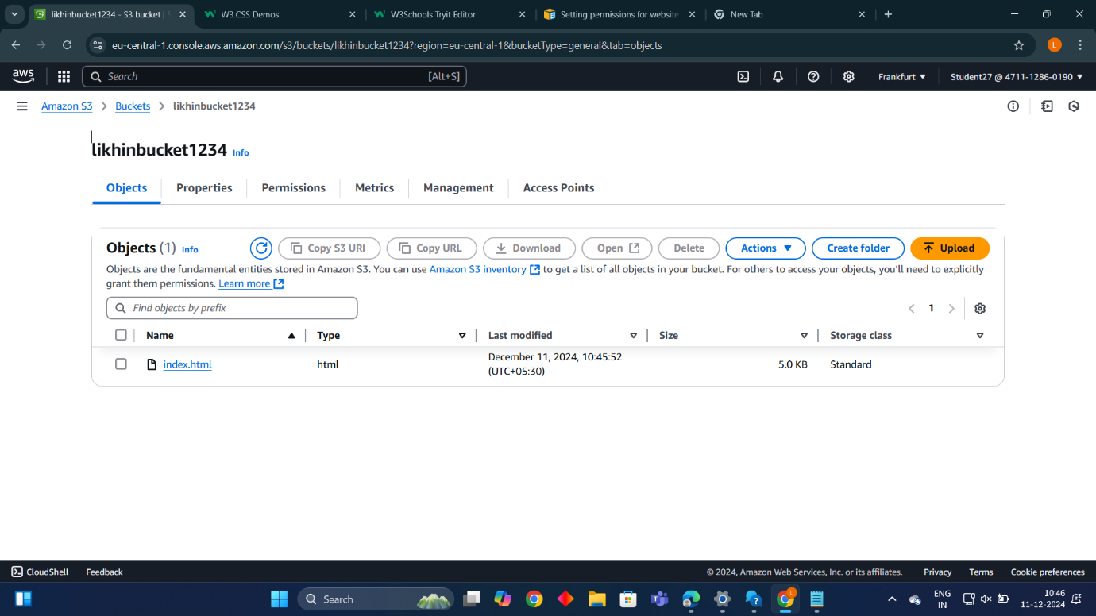

* **Setting permission for website access and add bucket policy:** 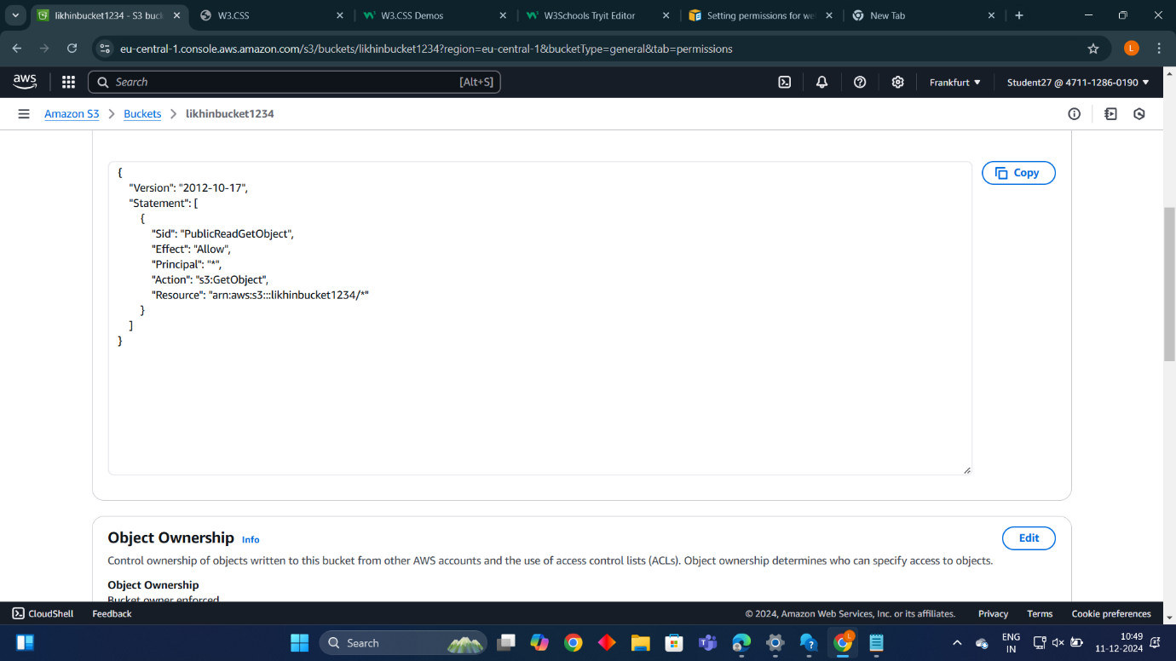
* **Static website hosting:** 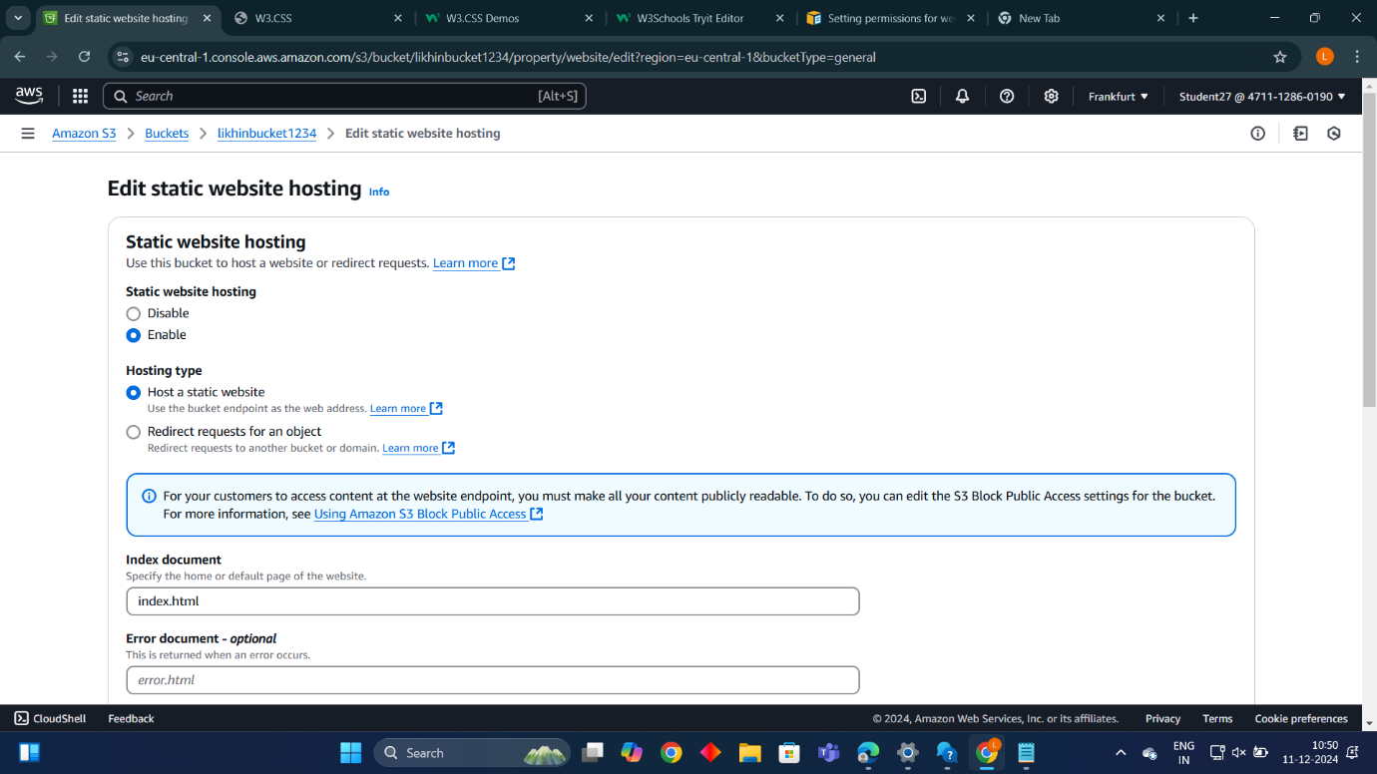

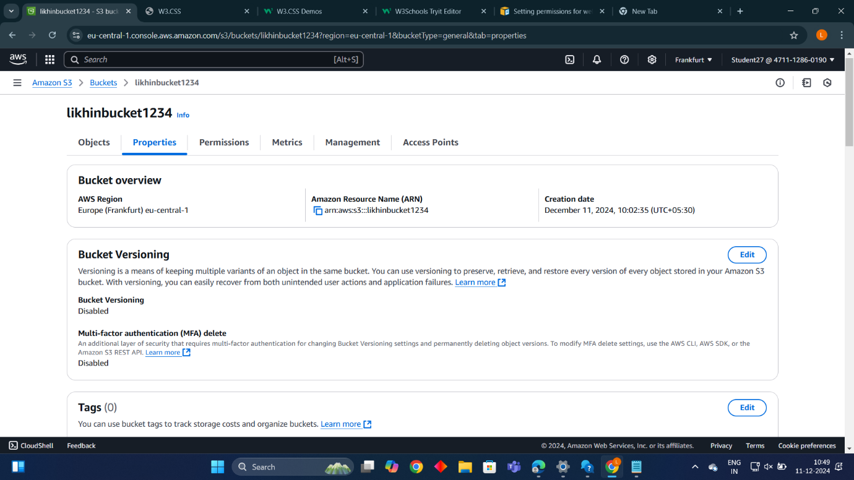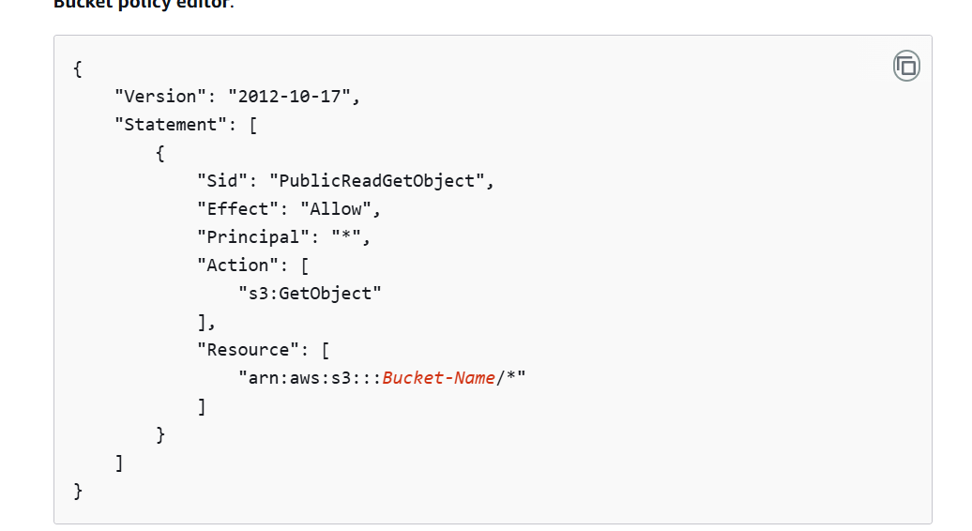

* **Final output**

